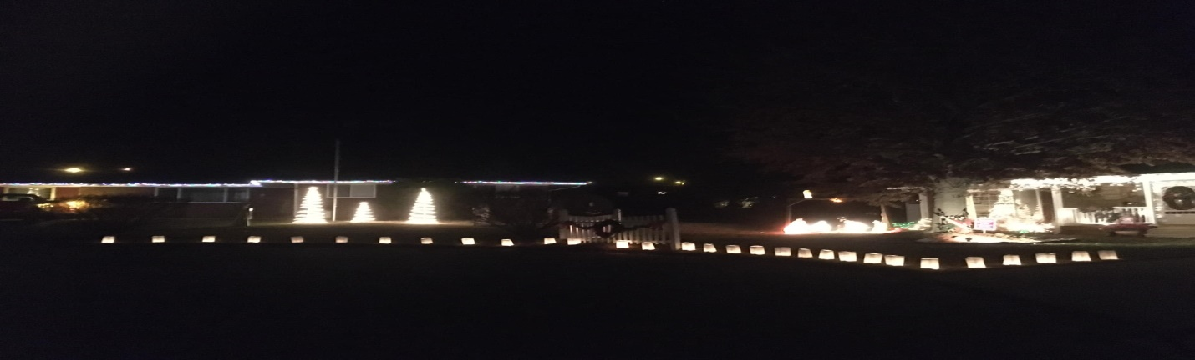
The holiday season is quickly approaching and we will again be participating in a holiday tradition, LUMINARY, in Ravenswood with all of you! Please join us in celebrating this holiday season by lining our homes, churches and businesses with candle luminaries! Help us “light the way” for Christmas on Sunday December 24th. Everyone will light their candles at 6:00 PM. In the event of inclement weather the luminary will move to December 25^{h}. We will post on Facebook if we have to change the date. The candles should burn long past midnight so we have several hours to enjoy the impressive sight.
If you are interested in participating, please fill out the attached form and place in the drop box at Ravenswood City Hall or mail it along with your payment before December 8th. The cost is $17 for 10 luminary bags. We suggest you place 1 luminaria bag per every 3 feet. Some choose to put names on the bags in memory of others. Do what works for you!
Kits will be available to pick up at Calvary Baptist Church (beside Ravenswood High School parking lot) on December 16th between 2-4 PM. If you can’t pick up your luminary kits, we will deliver them to you. Just mark your paid order form for delivery and we will bring it to your address during this time.
All proceeds go to the Charles Shaver Scholarship (501c charitable organization) which awards a scholarship to a senior each year from both Ravenswood and Ripley High Schools. This project is being provided in conjunction with The Charles Shaver Scholarship Fund and the Ravenswood Board of Parks and Recreation.

