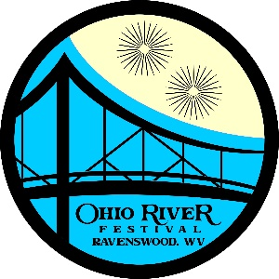
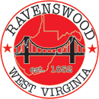
City of Ravenswood

Ohio River Festival

Meeting Agenda

Washington’s Riverfront Park
Thursday 7/17/2025 5:30 p.m.

- Welcome/Call to Order
- Approval of Minutes
- Old Business
- Financial Update
- New Business
- Next Meeting Date: TBD
- Adjournment

