RAVENSWOOD PARKS AND RECREATION MEETING
1 June, 6:00 PM 2026
Ravenswood Annex
600 Mulberry Street
Ravenswood WV

- Call to Order
- Roll Call
- Approval of Minutes from previous meeting
- Treasurer’s Report
- Public Forum
- Good of the Order/Superintendent’s Report
- New Business for Approval
  - Merger of museum director and superintendent job description
  - Recommending a new superintendent/museum director
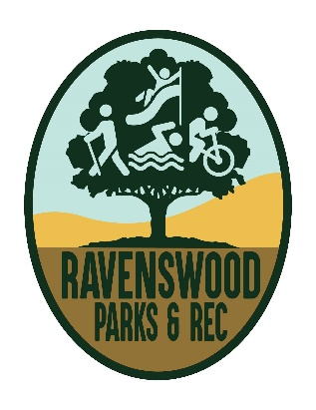
- Adjourn

