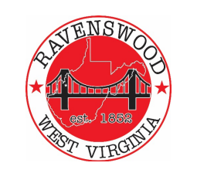
City of Ravenswood
Planning Commission Agenda
October 26 , 2023 – 6p
3rd Floor City Building
- Pledge of Allegiance

- Roll Call - Ritchie, Salser, Fox, Casey, Greening, Akers, Cady, Carmichael

- Public Forum

- Approval of Past Minutes – Meeting of September 28

- Downstream Strategies Community Plan Addendum Update - BrennanWilliams

  - Land Use and Regulation Assessment
    - Draft Proposal
    - PRO Federal Grant Opportunity
    - Proposal
  - Downtown Revitalization – OnTrack / Main Street
    - Organization
    - Application for On Trac
  - Final report reviews and timing

- Review of Management / Technical Owner Oversight Projects
  - Ph 2A and 2B Status
  - Sanitary Board

- Other Communications / Discussions
  - Ordinances and Modifications - Public Hearing – Council Approval
  - Advantage Valley 10 County Residential Assessment
  - BHE Status
  - Hillcrest Water Tank
  - WVU/JGH Clinic
  - Gafcon session – October 18

- Next Meeting(s) - Adjournment

