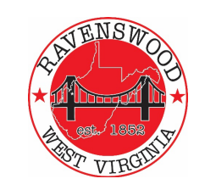
City of Ravenswood
Planning Commission Agenda
January 11, 2023 – 6p
- Pledge of Allegiance

- Roll Call – Ritchie, Akers, Casey, Fox, Greening, Salser, Cady, Carmichael –

- Public Forum - Comments solicited from public on ‘Addendum to City of Ravenswood Comprehensive Plan 2018’

- Approval Past Minutes –

  - October 26, 2023
  - November 30 ,2023

- Recommendations / passage of edits to final draft of Addendum to Comprehensive Plan

- Update (s)
  - Hillcrest Water Tank
  - McIntosh Hardware
  - Main Street / On Trac
  - Land Use Code / Zoning Updating
  - Phase 2A and 2B Sewage Project Status
  - Development of potentials site for residential capacity enlargement - Executive Session

- Building Permit(s) Status Tim – any approvals over last month – any pending

- Zoning Issues Tim

- Adjournment

