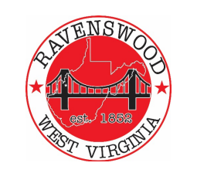
City of Ravenswood
Planning Commission Agenda
February 1, 2023 – 6p
- Pledge of Allegiance

- Roll Call – Ritchie, Akers, Casey, Fox, Greening, Salser, Cady, Carmichael –

- Public Forum

- Approval Past Minutes – January 11, 2024

- Review of Variance Committee Recommendation – 208 Virginia - Akers

- Review of Regional Residential Housing Capacity Analysis - Ritchie

- Building Permit(s) Status or Zoning - Salser

- Adjournment

