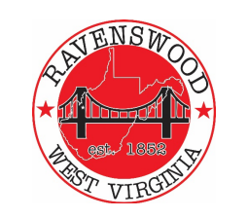
City of Ravenswood
Planning Commission Agenda
March 26, 2023 – 5:30p
- Pledge of Allegiance

- Roll Call – Ritchie, Akers, Casey, Fox, Greening, Salser, Cady, Carmichael –

- Public Forum -

- Approval Past Minutes – January 11, 2024

- Land Use Code Revision

  - Review 1st Rough Draft
  - Facilitation of Updates

- Building Permit(s) Status Tim
– any approvals over last month – any pending?

- Executive Session for Purposes of Citizen / Landowner Business Confidential Discussion

- Zoning Issues Tim

- Adjournment

